Task No & Title: Unit 7 | Unit Descriptor Unit Descriptor This unit defines the competency required to configure, use and optimise a computer operating system.
Title: | Use computer operating system
Suitable for Classes: | Certificate II in Information Technology
Area: | Technology & Enterprise
Teacher: | Mr Peter Faulks
Timeline | 1 Lesson
Date Due: | Today

Task Brief:

Files Required

Items highlighted in yellow are tasks for you to complete
Items in Purple are help tips
Certificate II in Information Technology
Use computer operating system

1 | ICAU1128B Operate personal computer | Pre | 20 hours
2 | BSBCMN106A Follow workplace safety procedures | Core | 10
3 | ICAD2012B Design organisational documents using computing packages | Core | 40
4 | CAU2005B Operate computer hardware | Core | 20
5 | ICAU2006B Operate computing packages | Core | 60
6 | ICAU2013A Integrate Commercial computing packages | Core | 25
7 | ICAU2231B Use computer operating system | Core | 20
8 | ICAW2001B Work effectively in an IT environment | Core | 25
9 | ICAW2002B Communicate in the workplace | Elective | 20
10 | ICAS2014B Connect Hardware Peripherals | Elective | 25
11 | ICAU2007B Maintenance of equipment and consumables | Elective | 15
12 | ICPMM263B Access and use the internet | Elective | 20
13 | ICAW2011B Work individually or as a team member | Elective | 20
14 | ICPMM321B Capture a digital image | Elective | 30

Explain the following computer Peripherals

1. Screen
A computer display, monitor or screen is a computer device capable of showing still or moving images generated by a computer and processed by a graphics card.
3 marks
2. Keyboard
Keyboards are designed for the input of text and characters, and also to control the operation of the computer. Physically, computer keyboards are an arrangement of rectangular or near-rectangular buttons, or "keys". Keyboards typically have characters engraved or printed on the keys; in most cases, each press of a key corresponds to a single written symbol. However, to produce some symbols requires pressing and holding several keys simultaneously, or in sequence; other keys do not produce any symbol, but instead affect the operation of the computer, or the keyboard itself.
3 marks

3.Mouse
A mouse is a handheld pointing device for computers. It is a small object fitted with one or more buttons and shaped to sit naturally under the hand.
The underside of the mouse houses a device that detects the mouse's motion. It is called a mouse primarily because the cord on early models resembled the rodent's tail, and also because the motion of the pointer on the screen can be mouse-like.
3 marks

4.System Unit
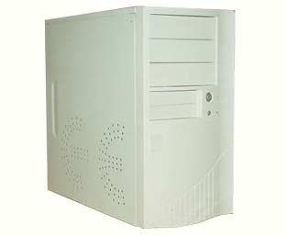
Usually a beige or dark grey box, it is the most essential part of the computer. It houses the processor (the ‘brain’), the various kinds of memory and the electronics to control all the other components. It also usually includes a fan, designed to keep the whole unit cool. The fan is responsible for the hum from the computer when you turn it on. The system unit may stand vertically on the floor (a tower) or horizontally on the desk, usually with the screen on top (a desktop unit). In a laptop or notebook computer, the system unit is usually built underneath the keyboard.
4 marks

5.Central Processing Unit
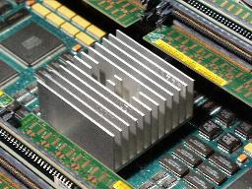
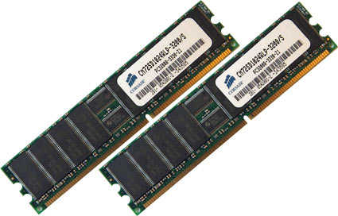
The processor chip and the electrics that support it are known as the central processing unit. The CPU is at the heart of the computer within the system unit, it performs calculations, controls logic flow and communicates with and controls the operation of the other parts of the computer system.
3 marks

6.Memory
There are a number of different kinds of memory, two of which are commonly talked about- Random Access Memory (RAM) and disk space. RAM is the computer’s working memory, an important factor in determining a computer’s speed. RAM is volatile, which means as soon as the power is turned off, whatever was in RAM is lost.

Another type of memory is called Read-Only Memory (ROM). ROM is where the computer stores its low level programs, the ones that tell the computer how to behave and how to treat different types of input devices. ROM differs from RAM in the way that it is not changed after the computer is assembled (you can read it, but not write to it).

Disk space is another type of memory. A disk is a device for storing information.

Disks record information in a similar way as music or video tapes, once information is recorded to a disk it remains there until it is changed or deleted.

The hard disk located in the computer (usually called the ‘C’ drive) (Windows) or Hard Drive (Mac) is a spinning magnetic disk on which computer data can be stored.
3 marks

7.Sound Card
A sound card is a piece of hardware that can be inserted into the motherboard of the computer to input and output sound under the control of computer programs
3 marks
Explain the following computer peripherals:

8.A Printer is…
a device that produces a hard copy of text and/or graphics. A hard copy is a physical reproduction of documents stored in electronic form, usually onto a medium such as paper.
5 marks

9.A Scanner is used to
…digitalizes a two dimensional image, such as sending a picture from a book to the computer screen, is used to input physical items or printed text and images into the computer.
5 marks

10.A Modem allows you to…
to connect the computer to the telephone network, allowing access to the internet and emails to be sent and received. Most computers today include a modem already installed in the system unit, but they can also be obtained as an external device that can be connected to the computer with a cable. Most modems can also enable your computer to function as a fax machine.
5 marks

11. Explain the difference between a CD-R, CD-RW, DVD-R and DVD-RW
A CD-R is able to be written to and therefore store either music or data in its memory. This information cannot be deleted or over written. Whereas A CD-RW is a CD that is able to be written to and store information, although the information is also able to be deleted or over written, and further information can be added to the disc.

A DVD-R is a CD with larger data storage capacity than a CD-R. It is used to store large amounts of data such as movies, whereas a DVD-RW is a DVD with equal storage capacities to a DVD-R, used to hold large amounts of data. The difference is the fact that a DVD-RW has the ability to erase and rewrite data to the disc.
5 marks

12 Explain an Ergonomic principle to help avoid eye strain
Take regular breaks use good lighting
5 marks

13 Explain an Ergonomic principle to help avoid physical strain.
Adjust chairs, monitors and computers to correct position, in relation to your body take breaks to ease overuse syndrome
5 marks

14 Describe the function of a computer operating system.
An operating system (OS) is a software program that manages the hardware and software resources of a computer. The OS performs basic tasks, such as controlling and allocating memory, prioritizing the processing of instructions, controlling input and output devices, facilitating networking, and managing files. A computer must have an operating system to be able to run other programs. An operating system can also be referred to as a computer platform.
First, the operating system rules the computer's roost, controlling all the individual computer components and making sure that everything gets along well. It's the actual brains of the operation, telling the hardware what to do next.
5 marks
15 Describe the boot process.
The typical computer system boots over and over again with no problems, starting the computer's operating system (OS) and identifying its hardware and software components that all work together to provide the user with the complete computing experience. But what happens between the time that the user powers up the computer and when the GUI icons appear on the desktop?
In order for a computer to successfully boot, its BIOS, operating system and hardware components must all be working properly; failure of any one of these three elements will likely result in a failed boot sequence.
16. What is the relationship between an application program, the operating system and hardware?
Application program must be suited to the operating system and have sufficient RAM to work effectively, the hardware being the CPU and peripherals should be able to manage the requirements of the application such as colour printer, stereo speakers.
5 marks

17. What are the general differences between the different computer platforms and their respective operating systems.
Windows uses a variety of operating systems such as 2000, XP, Vista and is text driven, it has only one resource fork and therefore is susceptible to viruses.

Mac uses OS (Operating System 10) and is mainly graphical but uses two file identifiers the resource forck and a data fork and is therefore more secure from viruses.

Linux is a more sophisticated system and has more stability than the Windows computer.

18. Draw a simple block diagram showing the interconnection of the various components of a computer.
Answer:

19. Write the name of the external hardware components and peripherals on the following diagram
Answers:
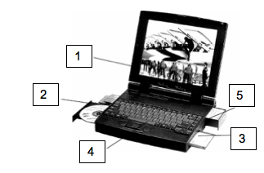

1. Monitor
2. CD DVD Drive

3. Floppy Drive
(Now a USB Drive)

4. Keyboard

5. Hard Drive

20. Label the parts on these computers
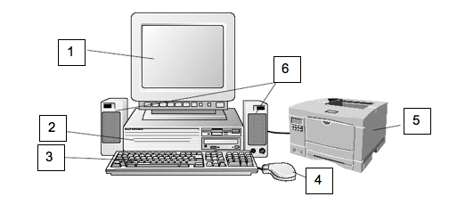
Answers:
1. Monitor
2. CPU
3. Keyboard
4. Mouse
5. Printer
6. Speakers

21. Describe the functions of computer hardware and associated OH&S standards and environmental considerations around hardware use and disposal of equipment

The manufacture of computers is a highly resource-intensive process that
uses significant quantities of energy, water and raw materials. In addition,
PCs contain hazardous materials that can be toxic to human health.
Therefore, from an environmental perspective, it is usually preferable to delay
disposal, which has the effect of ‘reducing consumption’ of PCs
and thereby reducing the environmental impacts associated with PC
manufacture. This involves considering whether disposal is really necessary
or whether it is possible to extend the useful life of the PC. Extension of useful
life could be achieved by considering whether an upgrade or modification of
the PC is possible, or whether the PC can be used to perform other functions
(for example, those less technologically demanding) elsewhere within the
business.

22. Label each of the following as hardware or software.

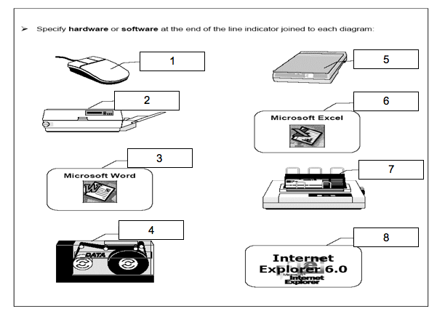
Answers must be detailed:
1. Mouse, Hardware
2. Printer, Hardware
3. Application Software Word Processing
4. Tape Drive, Hardware
5. Scanner, Hardware
6. Application Software Spreadsheet,
7. Dot Matrix Printer, Hardware
8. Application Software Web Browser

Save the work

Student Name: | Date submitted:
I declare this evidence to have been produced by me the undersigned.

Candidate’s signature:
Title of Portfolio evidence presented (include Unit No and section i.e. 03.05)
:-
□ Outcomes from learning programs (including self-learning and online learning)
□ Assessment feedback (from a trainer or assessor)
□ Observation checklists (from a workplace supervisor or assessor)
□ Written statements or references (including workplace supervisors, community leaders)
□ Job descriptions
□ Work journal
□ Work samples
□ Finished products
□ Product descriptions or specifications (supporting the product samples included)
□ Statutory declarations
□ List others (or delete any from above not provided)
- All work submitted to be word processed and spell checked.
- There must be at least two samples of evidence for each
Element within the Unit of Competency. This is sample 1 / 2
- All work submitted must be of a high quality and meet the
requirements of the Unit of Competency.
Other evidence (List each piece):
Assessor to complete
Evidence is Valid Sufficient Authentic Current
□ □ □ □

Assessor signature: _________________________________Date: _____________
Peter Faulks, BA Soc Sci, Grad Dip Ed, Cert IV AWT
Certificate II in Information Technology assessor/teacher
Assessor to complete

Student is declared Competent Not Yet Competent
□ □

Keep a copy of this report with your file for evidence

